The Rules for the ARA Factory Class are found in the American Rimfire Association Rule Book section 8.

"Is my gun approved for the ARA Factory Class?"

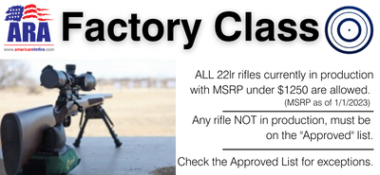

ANY rifle in current production that is tube or magazine fed and has a current MSRP of less than $1250 is approved. There is no need for these to be on the list. No rifle in current production under $1250 is going to be specifically listed as it meets the #1 criteria.

You can View, Download, and/or Print the flow sheet and ARA Factory Class Approved / Not Approved Rifle list as well as access the online fillable Factory Class Request Form. The request form is ONLY for rifles not in current production.

